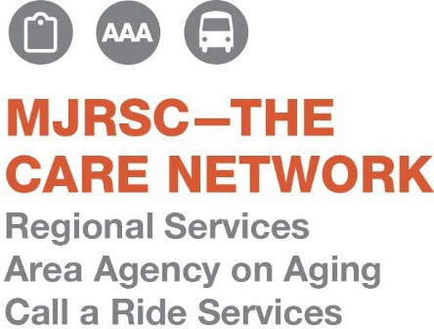

**Fall Fest Rental Agreement**

**Date**: November 1, 2025 **Event Time**: 8:00am-1:00pm **Set Up:** 7:30am

Applicant: Phone:

Email: Type of Vendor: _

This event will be indoors at Lewistown Senior Center. We ask that you stay for the entire event. Rentals include one 8ft long table and 2 chairs. We ask that these spaces only be for crafts, artisans, bakers, and vendors with products; please do not rent a table for yard sale or flea market types of uses. This event is a fundraiser for Mifflin & Juniata County Senior Community Centers to help fund our crafts, entertainment, outings, and other needs. We will be having a basket raffle; it is requested that you donate a basket for the raffle equal to or greater than $15.00.

1 Table incl. (2 chairs): $25.00 How many are requested:

Additional Donation: $ _

Total Fee: $

Please return this form to us by October 20th. Spots are offered on a first come, first served basis. You may print this off and mail it in with your payment made to: MJ-AAA, 25 Rothermel Dr, Yeagertown, PA 17099, or drop it off to us Monday-Friday from 8am-4pm. Please note Fall Fest in the memo line.

Contact Jen Feathers for more information at 717-242-1036 or email [lewistownctr@mymjrsc.com](mailto:lewistownctr@mymjrsc.com).